***Name- Harsh Singh Yadav***

***Intern ID- 16052***

***SQL Developer Task 3: Subqueries and Aggregations***

**Objective:**

The objective of this task is to use subqueries and aggregation functions to extract insights from a dataset. Specifically, we will analyze student performance data by calculating total scores, averages, and identifying top performers and second-highest scores.

**Project Steps**

**Step 1: Database Setup**

1. **Table: student**
   * **Fields:**
     + student_id (Primary Key)
     + name (Name of the student)
     + math_score (Math test score)
     + science_score (Science test score)
     + english_score (English test score)
     + total_score (Optional, can be calculated dynamically)
2. **Insert Sample Data:**
   * Insert sample data for multiple students with scores in Math, Science, and English.

**Step 2: Create Table and Insert Sample Data**

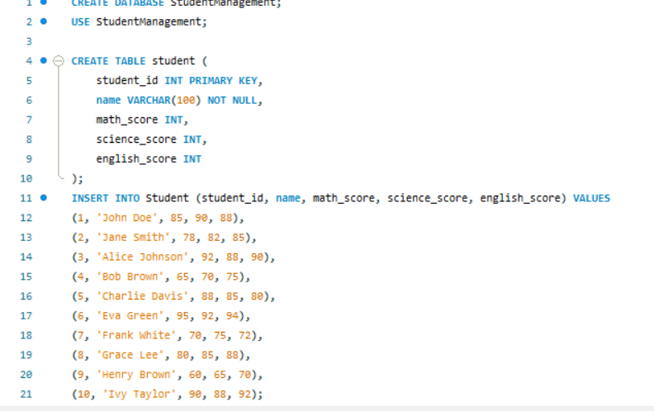

**Step 3: Tasks to Perform**

**Task 1: Identify Top Students by Total Scores**

**Query:**

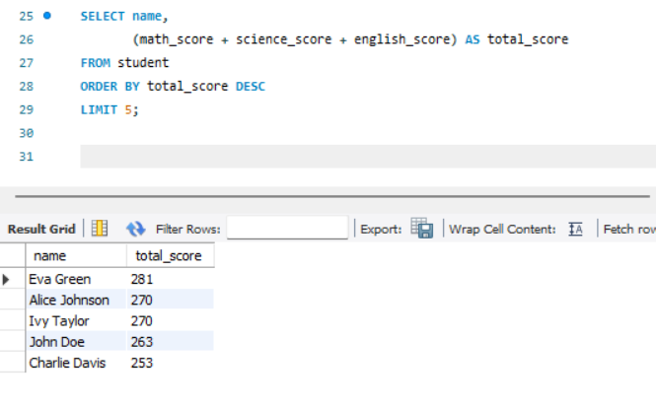

**Purpose:**  
This query calculates the total score for each student by summing their scores in Math, Science, and English. It then ranks the students by their total scores in descending order and limits the result to the top 5 students.

**Task 2: Calculate Averages Based on Specific Conditions**

**Query 2.1: Average Score of Students Who Scored Above 70 in Math**

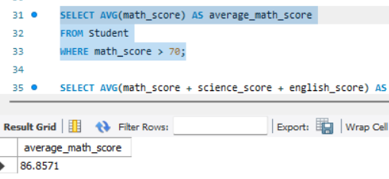

**Purpose:**  
This query calculates the average Math score for students who scored above 70 in Math.

**Query 2.2: Average Total Score of Students in a Specific Range (e.g., 200–250)**

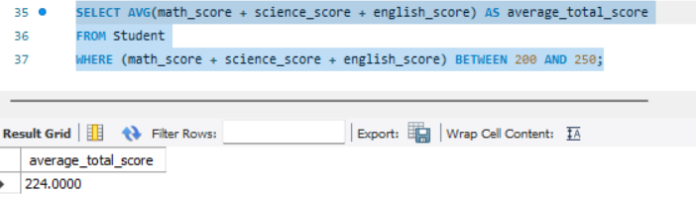

**Purpose:**  
This query calculates the average total score for students whose total scores fall within the range of 200 to 250.

**Task 3: Find the Second-Highest Math Score**

**Query:**

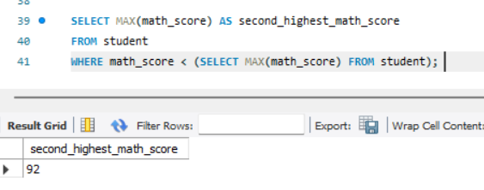

**Purpose:**  
This query identifies the second-highest Math score by first finding the highest Math score and then excluding it to find the next highest score.